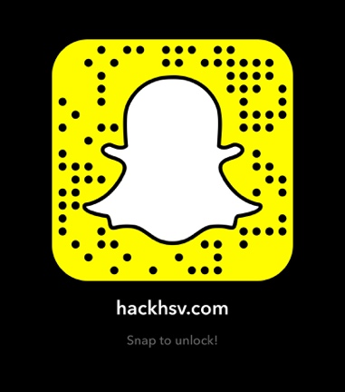

2nd Annual High School Coding Marathon

**CODE WITH FRIENDS!**

**WIN BIG PRIZES!**

**AGES 13-18!**

**For more info, go to hackhsv.com**

www.hackhsv.com

February 24, 2018

9:00am-10:30pm

Randolph School

Hack HSV